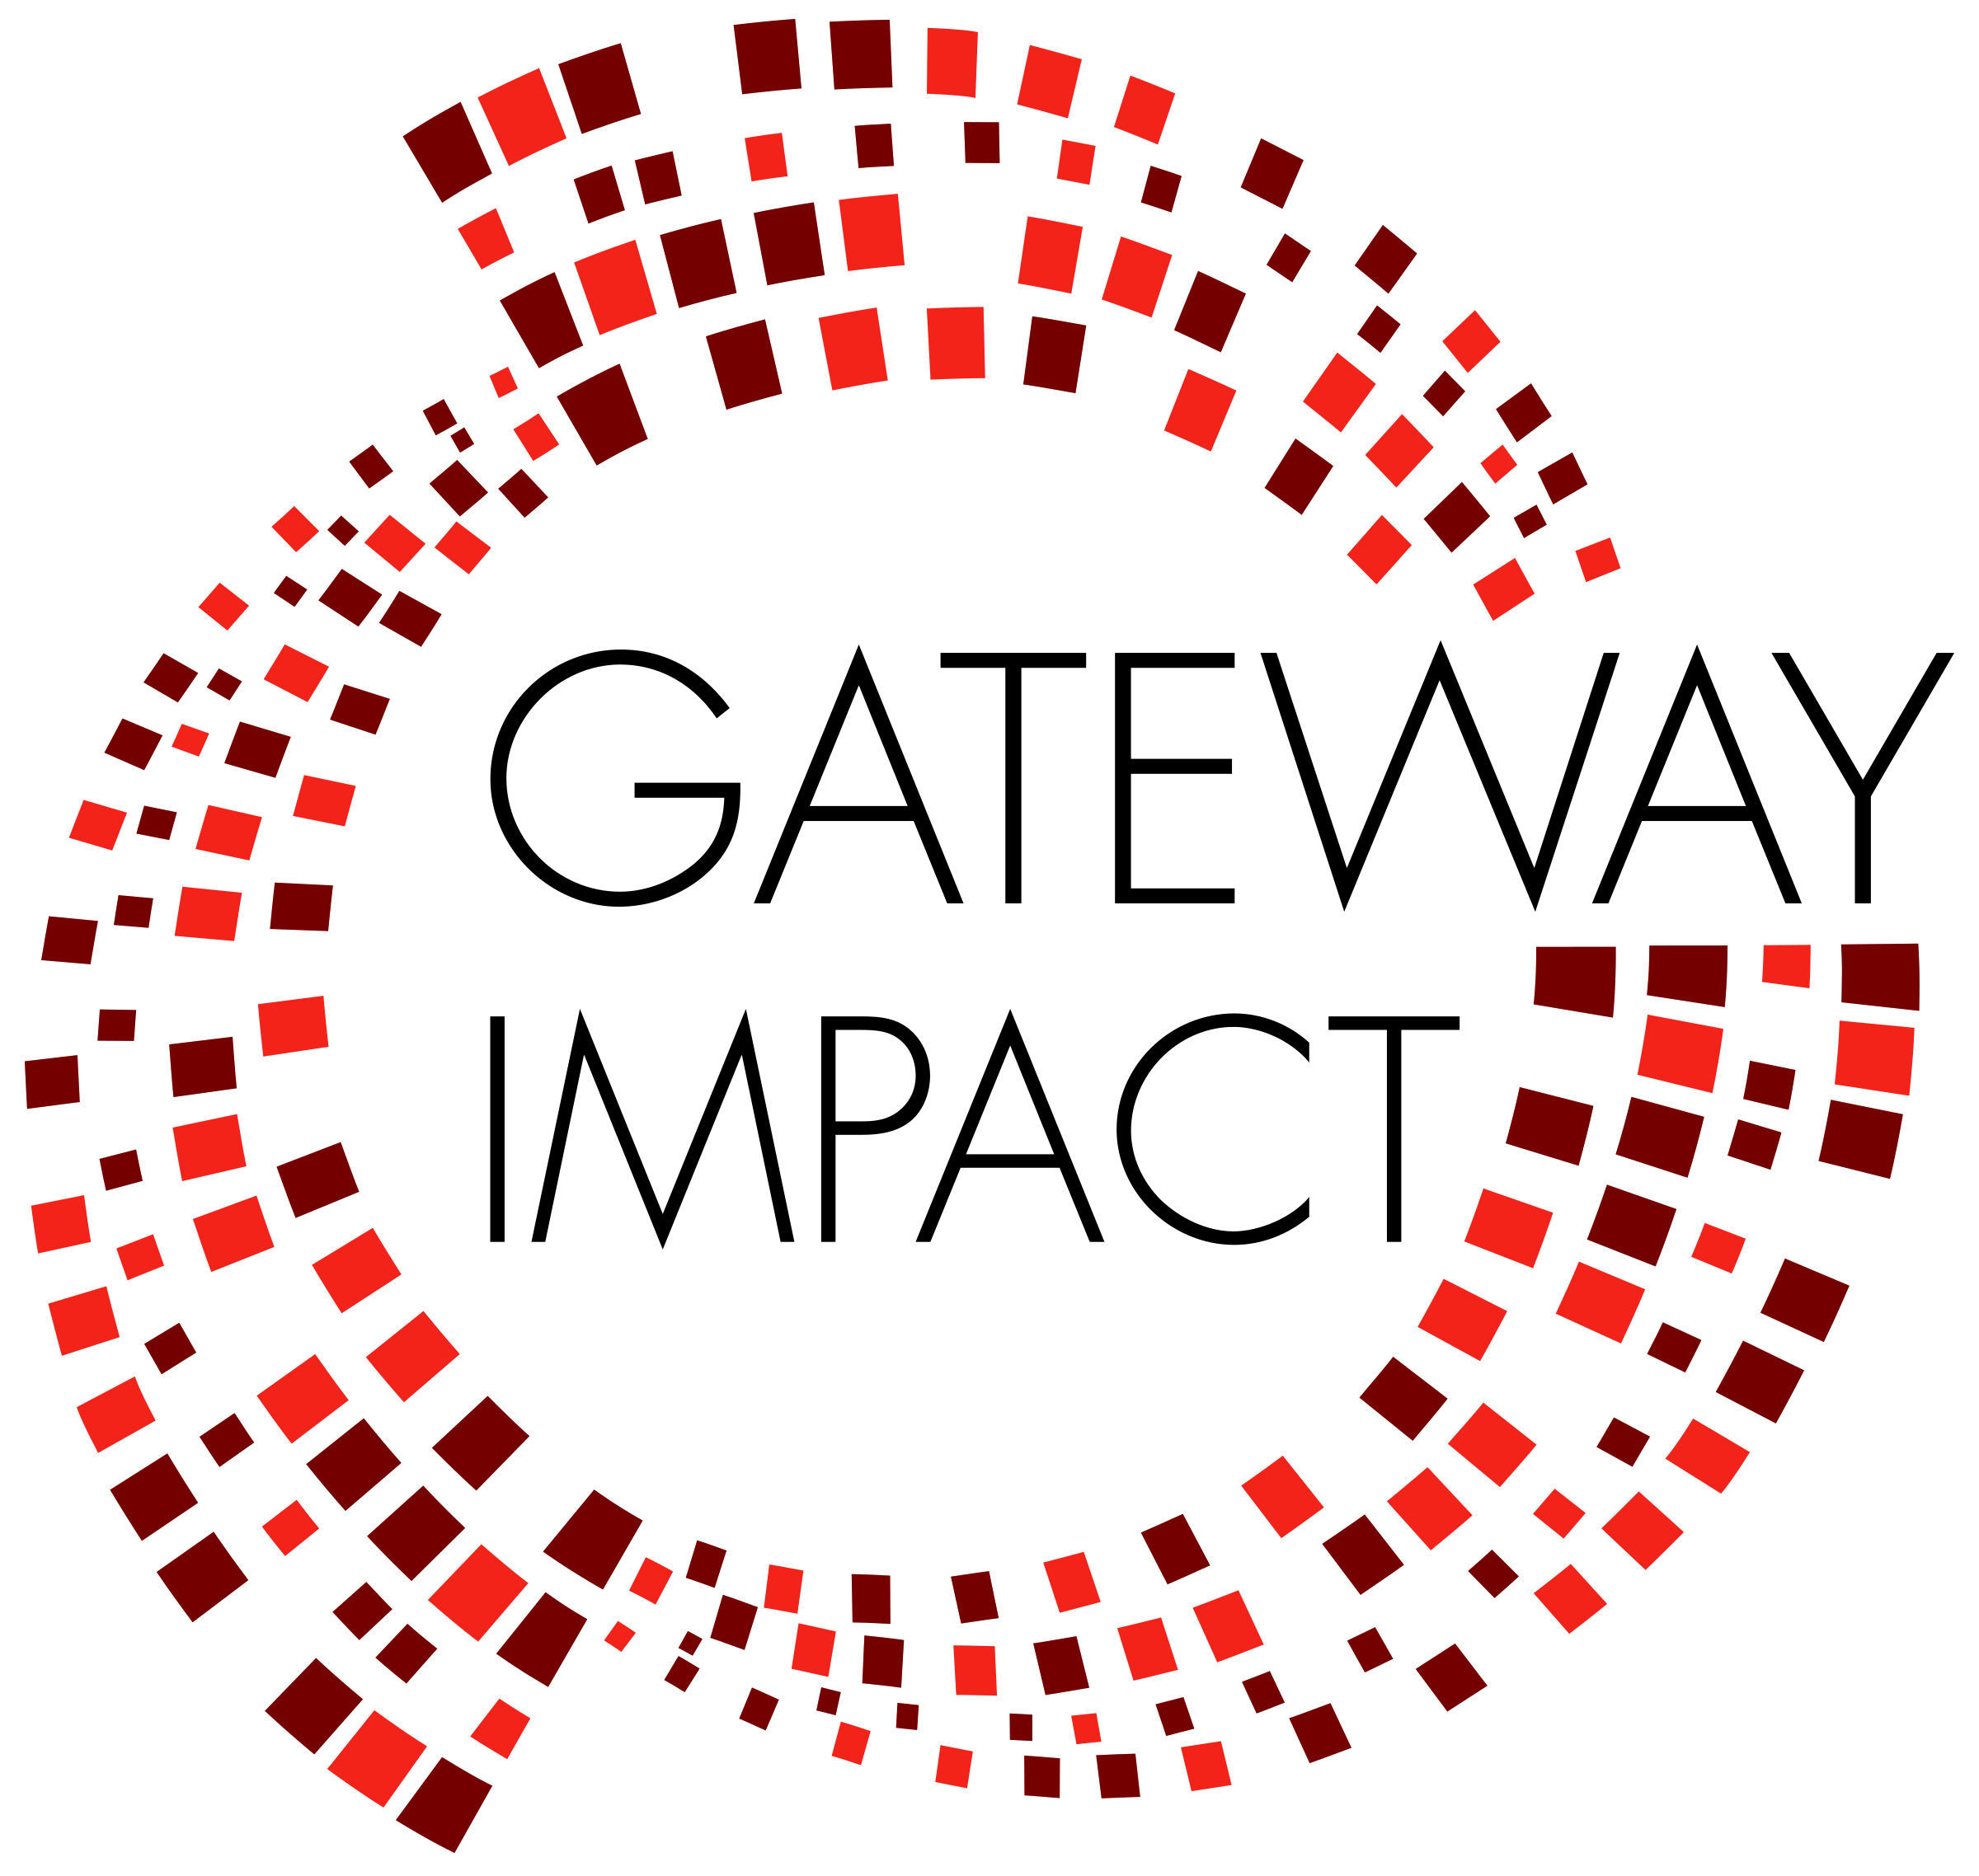
GATEWAY HIGH SCHOOL DISTANCE LEARNING PLAN

- Framework: Goal, Context, Core Beliefs, Guiding Principles
- Guide for Faculty & Staff
- Guide for Parents/Guardians
- Guide for Students

Distance Learning Framework

Context
This distance learning plan has been drafted with the specific context of the COVID-19 school closures in mind. The following contextual aspects have been identified and considered:

- Timing - This closure and move to online learning was unanticipated, and directives from the state and district may be forthcoming. As of now, this plan is intended to cover 8 weeks of learning in Q4.
- Equity - We serve a diverse population of students with varied learning needs, levels of independence, access to support at home and to technology.
- Faculty - We must consider the sustainability of our staff: we are affected both personally and professionally by the shelter-in-place order and the spread of COVID-19. Although distance learning is new to our school, our staff is committed to professional development and to meeting the needs of students, and we have specific staff members with expertise to help guide this process.
- Technology - Technology is both a barrier and an asset. In order to provide equitable access to distance learning we will ensure all students have access to devices and wifi. There are also many high quality tools available online for teaching and learning.

Core Beliefs
The following have been identified as core beliefs that ground the DLP in our mission and vision:

- Equity - We believe that all families want to provide their children with access to high quality education and learning. As educators we must differentiate our instruction so all students can access learning.
- Academic Proficiency and Rigor - We believe our role is to help students master content, think critically, and have access to and be prepared for college. We believe we can provide high quality instruction remotely, but will need to reconsider goals in light of the needs of the moment.
- Social-Emotional Development and Support - We believe our role includes helping students grow both academically and social-emotionally. We seek to foster feelings of safety and belonging for our students and families. We believe consistency and structure are important for students’ well-being. In this current situation it is important for us to provide support to our students and families.
- Technology as an Asset - We believe we can use technology to create effective learning experiences for students remotely.
- Faculty Growth and Sustainability - We believe in developing ourselves professionally in order to best meet the needs of our students. We believe this is an opportunity for faculty to grow and for our schools to innovate to better meet students’ needs. We know we can’t care for students if our work is not sustainable.

Distance Learning Plan Guide for Faculty & Staff

The goals of our Distance Learning Program (DLP) are to:
- Provide engaging, accessible, differentiated, student-centered learning experiences
- Provide structure and routine, connection to community, and space to attend to our humanity
- Support students to gain proficiency on a feasible set of Q4 learning goals given the challenges of the moment

Guiding Principles

- Attend to the personal and relational. Each student and family is going through a unique experience and set of challenges. Give spaces for students to reflect, share, reach out with needs, etc. Find ways for students to come together and interact.
- Start with the familiar. Ease the transition to online learning by recreating routines as applicable, and using familiar platforms and processes.
- Less is more. Recognize that none of us are operating at full capacity. Keep directions and tasks clear and straightforward. Students are also managing multiple assignments across many classes without the structure and support provided on campus.
- Seize the moment. As applicable, embrace that this is a unique experience in all of our lives. How can students’ learning experiences relate to this historical moment?
- Leverage technology’s strengths. Distance learning can allow students to move at their own pace and have more agency in how and when they learn, and how they show what they know. Don't be afraid to reimagine how to engage and support students.

CLASS COMPONENTS | HOW, WHEN
Learning Experiences | Teachers will post lessons on Google Classroom by 9am on Tuesday/Wednesday, and Thursday/Friday when they normally have class. These could be videos, resources/tasks, activities.
Assignments & Feedback | Teachers will assign at least one assignment per week to be assessed and students will get feedback on that assignment.  Students should expect to spend 1-2 hours for each class, each week including instructional time and independent/group work.  Students will have at least 48 hours to complete assignments, and assignments will be due at midnight (rather than during the day when students may not be able to access devices).  Teachers will update PowerSchool by 5:00pm on Mondays with completed and missing work.
Support | Teachers will be available during designated Monday Office Hours and will respond to student/parent email in a timely way.
Connection | Teachers will provide at least one opportunity for students to connect with each other each week. This could be through an optional synchronous learning session, pair/group assignments, or other means.  Synchronous learning will not be required, however, since it’s not an option for many families because of scheduling and other constraints.
Assessment & Grading:  - Equitable given current situation & varied challenges for students/families  - Prompts students/families/teachers to notice missing assignments  - Solves fairness around kids trying, but not meeting standard  - Set a baseline so kids don’t check out completely  - Sustainable for teachers  - Not doing harm to students’ chances to earn credit, graduate, and maintain college admission  We grade at Gateway in order to communicate to students and stakeholders students’ academic skills, academic knowledge and Process of Learning skills, so that students self evaluate, receive appropriate support and grow. | We will likely need to adjust our approach given new information from CDE, SFUSD, etc. When in doubt, use these basic guidelines:  -Focus on assessment and grading for communication of learning, rather than for accountability.  -Avoid penalizing kids for obstacles in distance learning:  - Enter “missing” rather than 0 or 1 for missing/incomplete assignments  - If a student is not engaging with any assignments:  - At the end of the first week, enter “Incomplete” as the overall Q4 grade.  - RTI team will be doing follow-ups for students not engaging with work across classes.  - If a student is not engaging in your class only, please follow up.  - Accept late work without penalty.  -Given the barriers to access and support in a distance learning environment, we are adjusting our category weighting:  - 80% POL: formative assessment grades, learning activities  - 20% Proficiency: summative assignments, projects  -We will not administer final exams.

Questions to Guide Teacher Planning

● Which of the key learning targets and skills previously identified for upcoming teaching and learning are essential and feasible given the increased demands of this time? Which learning targets and skills are most transferable to a remote experience?

● What are the authentic learning opportunities that have resulted from this crisis? Where might my students’ curiosity and motivation open other new possibilities? In what ways can we encourage choice?
In what ways can we encourage service and helping others?

● How can I design remote learning experiences that address the varied needs of our learners? How can I minimize barriers and make learning experiences accessible for all students?

● How can I help my students manage the worry, fear, or isolation they may be experiencing
as a result of this crisis?

● How can I leverage digital platforms to provide learning experiences rich in engagement,
social interaction, and feedback?

● How will I assess student learning in meaningful ways that take into account the limited opportunities for support and do not penalize students for the limitations of this moment?

Possible Process and Tools for Setting up Distance Learning

- Set up or dust off Google Classroom, enter code here
  - How to set up Google Classroom (see tutorial here)
  - Turn off assignment notification on the stream, just use for daily announcements
  - Set up topics for organization purposes
  - Create assignments and comment on them
  - Show students how to submit assignments
- Determine format for pushing out lessons to students (Hyperdocs are useful here because they are self-paced and self-contained):
  - Google Slides Hyperdocs: Can include all kinds of multimedia (example here & here)
  - Google Docs: (example Math lesson here)
  - Interactive Google Slides with Pear Deck: Can be set up to be self paced. Students answer questions that teacher poses (see tutorial here)
- Use video for direct instruction
  - Screencastify (see tutorial here)
  - Zoom tutorial and a tutorial about breakout rooms)
  - Google Hangout Meets tutorial
  - Explain Everything: online
- Teacher curates content for students to learn about a topic. Many platforms not only have pre-created content bundles, they also have differentiated content so you can personalize instruction for your students.
  - Newsela: differentiated reading (see tutorial here)
  - Nearpod: instructional platform w/ content and formative assessments built in. Can be added as a Google Slides add-on and integrated with a hyperdoc
  - Khan Academy: tons of free content for personalized learning
  - Freckle: Differentiation platform (not sure how much is free right now)
  - Edpuzzle: Make interactive videos for students
  - Flocabulary: Hip hop videos & lessons (e.g. students can make their own hip hop songs)
- Students process what they’ve learned and demonstrate understanding
  - Post what they’ve learned to Padlet (see example here)
  - Teacher or student makes Google Forms quiz
  - Socrative Online Quizzes
  - Seesaw: Make learning visible, show what they know
  - Create their own Google Slides (see example here, tutorial here)
  - Book Creator (example here - may not be able to access, tutorial here)
  - Soundtrap: Make a podcast (Potential to make something really interesting here).
  - Digital Comics: (example here, tutorial here)
  - Graphic Design w/ Canva or Adobe
  - Short videos w/ Adobe Spark
  - Make a webpage w/ Adobe
  - Post a blog entry

- Have students post their work for others to see and comment on, teachers provide feedback
  - Use the Nearpod bulletin board
  - Padlet
  - Google Classroom conversations
  - Google Sites class website
  - Flipgrid

Faculty & Staff Roles & Responsibilities
GPS Distance Learning Team | ● Develop DLP with community input  ● Adjust DLP based on feedback  ● Recommend resources for providing instruction, support, and remote feedback to students
Administration & Leadership Team | ● Communicate DLP with all stakeholders  ● Support faculty to make sense of and plan for implementation of DLP  ● Develop systems and structure to support DLP success  ● Monitor DLP implementation and effectiveness, get feedback, adjust accordingly  ● Help teachers implement DLP effectively
Leadership Team & Subject Area Leads | ● Support teachers and teams to design, implement, and improve DLP through collaboration, resource-sharing, reflection, and feedback  ● Ensure that each subject area teacher has support they need  ● Monitor and respond to subject area challenges and queries
Teachers | ● Use the distance learning goal, guidelines, and suggested process to guide your work  ● Collaborate with other members of your grade team or discipline to adjust Q4 plans for a distance learning environment  ● Communicate with students (and their parents) who are not engaging with work or need more support  ● Provide timely feedback to support your students’ distance learning
Learning Specialists | ● Support teachers with scaffolding assignments, providing accommodations, and differentiating lesson and activities  ● Provide small group or one-on-one support for students on caseload  ● Check in regularly with students on caseload

Advisory Teachers | ● Provide guidance and support for students’ well-being and academic progress  - Check in on grades (powerschool) once a week and contact students to support any academic issues  - Individually contact any advisees failing multiple classes to help with organization, prioritization and online issues  - If required, contact parents to troubleshoot work completion issues  - Act as a family liaison for students with issues completing remote work, such as technology, organization, other responsibilities etc.  ● Weekly zoom meeting with whole advisory to provide peer and community support and sense of normalcy- OPTIONAL
Counselors | ● Offer individual tele-counseling meetings as needed for those in their current caseload during school hours  ● Provide phone parent and student consultation to address mental health related concerns as needed, during school hours  ● Provide mental health resources as needed
College Counselors | ● Evaluate timeline for graduation requirements, class credit, and testing deadlines  ● Host online Office Hours at set times for students to call in and access support.  ● Encourage students, parents, and guardians to schedule online meetings as needed  - Monitor announcements from CollegeBoard regarding AP, SAT, and ACT testing updates
Office Managers | - Support outreach to families related to tech needs and distance learning (e.g. make calls)  - Help with follow up calls to students and families who are not connected and engaging in distance learning (e.g. similar to attendance calls)
Student Activities | - Develop ways of engaging the school community remotely  - Consider opportunities for students to be build connection  - Work on remote avenues for ritual, service, and celebration
Partnerships | - Continue to provide opportunities to students remotely  - Communicate with community-based partners to get up-to-date information

Gateway Distance Learning Guide for Parents/Guardians

What are the goals of distance learning?

- Provide engaging, accessible, differentiated, student-centered learning experiences
- Provide structure and routine, connection to community, and space to attend to our humanity
- Support students to gain proficiency on a feasible set of Q4 learning goals given the challenges of the moment

What will the week look like?

Who | Monday | Tuesday | Wednesday | Thursday | Friday
Teachers | -Hold Office Hours  -Enter grades by 5pm on Powerschool  -No new assignments given | -Post on Google Classroom by 9am for A-D blocks | -Post on Google Classroom by 9am for E-G blocks | -Post on Google Classroom by 9am for A-D blocks | -Post on Google Classroom by 9am for E-G blocks
Students | -Attend Office Hours as needed  -Check grades on PowerSchool after 5pm | -Check GC  -Work on and turn in assignments  -Reach out for help via email if needed | -Check GC  -Work on and turn in assignments  -Reach out for help via email if needed | -Check GC  -Work on and turn in assignments  -Reach out for help via email if needed | -Check GC  -Work on and turn in assignments  -Reach out for help via email if needed
Parent/Guardian | -Encourage students to attend Office Hours  -Check grades on PowerSchool after 5pm | -Check in with student about Google Classroom assignments and daily schedule | -Check in with student about Google Classroom assignments and daily schedule | -Check in with student about Google Classroom assignments and daily schedule | -Check in with student about Google Classroom assignments and daily schedule

How will my student be graded?
Given the uncertainty and the stressors of this time, we are prioritizing the following:
  - Keeping students learning and growing through engaging curriculum, encouragement, and follow-up.
  - Not penalizing students for the challenges of this moment. We are accepting late work, and using the PowerSchool code “missing” rather than a grade of zero for missing work.
  - If a student is not engaging with work at all, their grade will be an Incomplete until work begins.
  - Given the barriers to access and support in a distance learning environment, we are adjusting our category weighting:
- 80% POL: practice, learning activities
- 20% Proficiency: summative assignments, projects
How can I support my student?

This is a complicated and challenging time for families. Each family’s circumstances and needs are unique. These tips are intended to be a resource for developing a plan that will work for your family:

1—Establish routines and expectations
Routine supports learning and provides a sense of safety for students. As much as is feasible for your family:
- Keep sleep schedules consistent
- Set regular hours for schoolwork
- Discuss and agree on the family’s expectations for device use, how to share space for schoolwork, schoolwork completion, communication, check-ins on progress.
- Write these agreements down and make them visible in the home.

2—Begin and end each day with a check-in
- Morning check-ins set the course for the day:
  - What is your child learning today? What are their learning goals and tasks?
  - How will they spend their time?
  - What resources do they require? What support do they need?
- End of day check-in helps everyone feel accountable, accomplished and helps improve the process for the next day:
  - What did you learn and accomplish today?
  - What worked in your learning process today? What needs work for tomorrow?

3—Balance independence and supervision
- Depending on students’ ages and capacities, they may be able to step up and be more independent in their learning.
- Students will also need monitoring; regularly check their Google Classroom and PowerSchool to verify that they’re on track.

4—Address physical and social-emotional needs
- Encourage your child to be active in some way during the day-- even doing chores can get them moving!
- Regularly check in with your child about how they’re feeling. It’s normal to be anxious, preoccupied, sad, and upset during an unprecedented time like this. Naming what they are feeling is an important step.
- Use resources: Link here
- Help your child find ways to connect with friends while maintaining social distance.

5—Be flexible
- Plans may need to change based on new direction from the state or city, on family or individual needs, or other circumstances.
- Be gentle with yourself-- these are unprecedented times for parents in particular. We can only do our best.

Parent/Guardian Roles & Responsibilities
● Establish routines and expectations
● Monitor communications from your children’s teachers
● Begin and end each day with a check-in
● Address physical and social-emotional needs
● Be flexible
For questions about ... Contact/Reference...
...a course, assignment, or resource | ...the relevant teacher  ...Google Classroom
...a technology-related problem or issue | Gateway Tech Support:  - VOICE: 415-656-8747  - TEXT: 415-656-8747  - EMAIL: familytechsupport@gatewayps.org
...a personal or academic concern | ...Advisor, or counselor/Resource Specialist if applicable
...social-emotional concern or mental health concern | Director of Counseling Services, Saundre Allen (sallen@gatewayhigh.org)  Additional resources:  Comprehensive Child Crisis: (415) 970-3800  S.F. Suicide Prevention: (415) 781-0500
...other issues related to distance learning | GHS: Rebecca Wieder (bwieder@gatewayhigh.org)

Gateway Distance Learning Guide for Students

What are the goals of distance learning?
- Keep you learning by providing engaging, relevant learning experiences at your level
- Provide structure and routine, connection to community, and space to attend to our humanity
- Support you to gain proficiency on a reasonable set of learning goals given the challenges of the moment

What will the week look like?

Who | Monday | Tuesday | Wednesday | Thursday | Friday
Teachers | -Hold Office Hours  -Enter grades by 5pm on Powerschool  -No new assignments given | -Post on Google Classroom by 9am for A-D blocks | -Post on Google Classroom by 9am for E-G blocks | -Post on Google Classroom by 9am for A-D blocks | -Post on Google Classroom by 9am for E-G blocks
Students | -Attend Office Hours as needed  -Check grades on PowerSchool after 5pm | -Check GC  -Work on and turn in assignments  -Reach out for help via email if needed | -Check GC  -Work on and turn in assignments  -Reach out for help via email if needed | -Check GC  -Work on and turn in assignments  -Reach out for help via email if needed | -Check GC  -Work on and turn in assignments  -Reach out for help via email if needed
Parent/Guardian | -Encourage students to attend Office Hours  -Check grades on PowerSchool after 5pm | -Check in with student about Google Classroom assignments and daily schedule | -Check in with student about Google Classroom assignments and daily schedule | -Check in with student about Google Classroom assignments and daily schedule | -Check in with student about Google Classroom assignments and daily schedule

How will I be graded?
Given the uncertainty and the stressors of this time, we are prioritizing the following:

  - Keeping you learning and growing through engaging curriculum, encouragement, and follow-up.
  - Being flexible given the challenges of this moment. We are accepting late work, and using the PowerSchool code “missing” rather than a grade of zero for missing work.
  - If you are not engaging with work at all, your grade will be an Incomplete until work begins.
  - Given the barriers to access and support in a distance learning environment, we are adjusting our category weighting:

- 80% POL: practice, learning activities
- 20% Proficiency: summative assignments, projects

Student Roles & Responsibilities
● Work with your family to set up a schedule, space, and routine for school work.
● Check Google Classroom and Gateway email daily.
● Complete assignments with integrity, academic honesty, and your best effort.
● Utilize resources and communicate proactively with your teachers if you cannot meet deadlines or require additional support.
● Collaborate and support your peers in their learning.
● Comply with Gateway’s Handbook and Technology Acceptable Use Policy, including expectations for online etiquette and behavior
● Proactively seek out and communicate with other adults as needed (see below).
● Participate in Zoom calls responsibly and in line with the following norms:
-Use school-appropriate, kind language
-Respect One Mic
-Only the teacher will share the screen, unless explicitly asking for students to do so
-Students may be muted depending on the needs of the activity or discussion. Do not unmute if muted.

For questions about ... Contact/Reference...
...a course, assignment, or resource | ...the relevant teacher  ...Google Classroom
...a technology-related problem or issue | Gateway Tech Support:  - VOICE: 415-656-8747  - TEXT: 415-656-8747  - EMAIL: familytechsupport@gatewayps.org
...a personal, academic or social-emotional concern | ...Advisor, or counselor/Resource Specialist if applicable  ...Wellness resources

Guide to Google Classroom for Parents/Guardians

