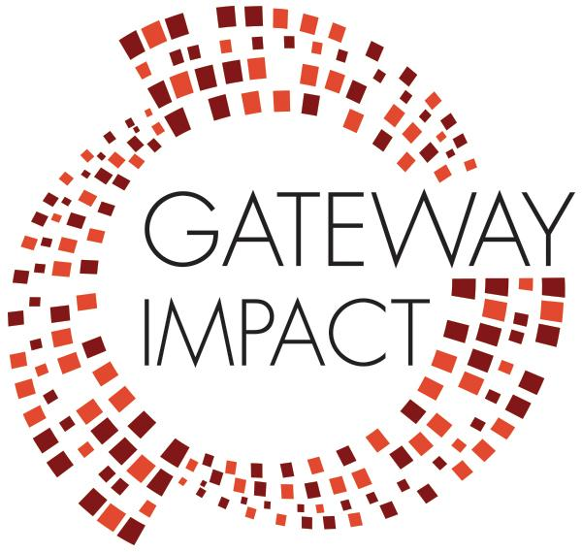

Questions to Guide Teacher Planning
GPS leaders developed these questions as “guideposts” to help teachers develop distance learning lesson plans that are relevant to students in this unique time, sustainable for those implementing them, and prioritize student equity and well-being. Suitable for individuals or teams.

● Which of the key learning targets and skills previously identified for upcoming teaching and learning are essential and feasible given the increased demands of this time? Which learning targets and skills are most transferable to a remote experience?

● What are the authentic learning opportunities that have resulted from this crisis? Where might my students’ curiosity and motivation open other new possibilities? In what ways can we encourage choice? In what ways can we encourage service and helping others?

● How can I design remote learning experiences that address the varied needs of our learners? How can I minimize barriers and make learning experiences accessible for all students?

● How can I help my students manage the worry, fear, or isolation they may be experiencing as a result of this crisis?

● How can I leverage digital platforms to provide learning experiences rich in engagement, social interaction, and feedback?

● How will I assess student learning in meaningful ways that take into account the limited opportunities for support and do not penalize students for the limitations of this moment?

